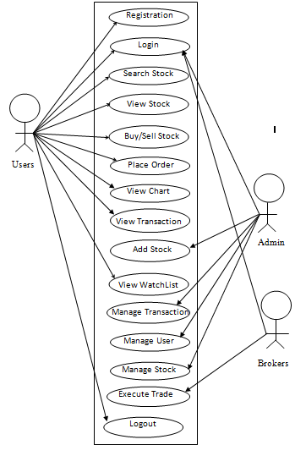

View Chart

Admin

Logout

Manage Transaction

History

hi

View Transaction

hi

View Transaction

History

Order Stock

Manage Stock

Manage User

View WatchList

Users

Place Order

Buy/Sell Stock

Search Stock

Login

Registration